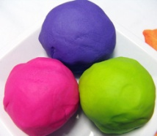
Homemade Playdough Recipe
3 cups plain flour
1 1/2 cups salt
3 cups water
3 tablespoons oil
3 teaspoons cream of tartar
Food colouring
Put ingredients in a saucepan over moderate heat. Stir continuously. Remove from the heat when the mixture comes away from the sides of the pan. The temperature of the mixture at this point is just bearable to touch. Cool and store in a plastic container or bag. It will last about a week stored in the fridge.

Try adding:
* Food flavourings to your playdough. Cocoa powder works well too!
* Different textures to your playdough. For example: Glitter or Pasta.
We hope you have fun and if you would like to bring any of your dough into playgroup to share with us we would be really pleased to see what you have made.

